

**Final Project Website for Social Media Website / FocusON-X.**

**2023-24 CST2120 Web Applications and Databases**

**Coursework 2: Final Project Website**

**Module Teacher:**

**Dr David Gamez - Module leader (Hendon)**

**Adam Philpot (Hendon)**

**Created by Arbaaz Ali Hussain - M00872279**

**Submission date: 12/04/24, 16:00 to 18:00 pm**

**Middlesex London University Computer Science School**

**Word Count: 1549**

Table of Contents

Introduction 3

Security, Privacy, and Legal Issues in FocusON-X 4

Security Issues: 4

Steps That Have Been Taken to Address the Security Issues: 4

The Future the Precautions for the Security Issues: 4

Privacy Issues: 5

Steps That Have Been Taken to Address the Privacy Issues: 5

The Future the Precautions for the Privacy Issues: 5

Legal Issues: 6

Steps That Have Been Taken to Address the Legal Issues: 6

The Future the Precautions for the Legal Issues: 6

Conclusion: 7

The Social Media Website / FocusON-X Frontend Screenshots 7

The Social Media Website / FocusON-X Postman /Thunder Client Screenshots 16

# 

# Introduction

In this project documentation, I have been tasked with developing a social media website to be accessed via web browsers. The inception of the FocusON-X website arises from the ambition to amalgamate the most desirable features of popular social media platforms such as Instagram and YouTube, while introducing novel experiences for users. The primary objective of this endeavour is to deliver a social media platform that not only fulfils design and functionality requirements but also emphasizes user engagement and unparalleled satisfaction in their interactions with the platform.

The decision to integrate elements from Instagram and YouTube into FocusON-X was inspired by the aim to create a platform that is both familiar and distinctive. Both Instagram and YouTube have been pivotal in the digital landscape, offering unique avenues for users to connect and share content. By blending aspects from these platforms, FocusON-X intends to provide users with a platform that evokes a sense of nostalgia while also offering forward-thinking features and functionalities. Throughout this project, careful attention will be given to ensuring that FocusON-X delivers an intuitive and enjoyable user experience, fostering meaningful interactions and content sharing among its users.

Furthermore, the project key objectives have been providing a user with a state of the arts registering and login in method alongside with a logging out feature which has been. As well as the ability to post the users content through his website and store it in its own server, where data can be access intensely. And alongside with the ability to view the content on the website and navigate effectively and finally search and follow other users on the website and view different type various content such as images and videos.

The last segment Is comprised of two elements. The first element being the security, privacy legal issue in here will describe the various aspects of the website and this term, thus discussion the effect that cannot occur on the website and discussing the steps in the future that can be used to eliminate unsolved issues which can emanate at any occurring time if not resolved.  
  
The second element being providing all the screenshots of the frontend of the website, postman/ thunder client displaying all of its functionalities and inputs & outputs that has been initiated.

# Security, Privacy, and Legal Issues in FocusON-X

## Security Issues:

Security is an utmost important concern for any online platform / website in correctly times, especially the platforms that deals with user data and interactions. Some of the potential security issues for the FocusON-X include the following:

* **Data Branches:** The unauthorized access to one or multiple user ‘s data, this includes the user’s personal information and content, thus could lead to breaches of privacy and trust.
* **Malware and Phishing Attacks:** The users might be beleaguered by malware or phishing attacks through the uses of malicious links or downloads on the platform of the website knowingly or unknown has potential to be a victim of a malicious attack.
* **Account Hijacking:** The poorly used technique for the authentication function or vulnerabilities within the website, therefore it could allow for malicious hackers to be able to hijack the user accounts within the platform.

## Steps That Have Been Taken to Address the Security Issues:

To mitigate those protection risks, FocusON-X implements numerous measures:

* **Encryption:** The user data is encrypted both in transit and at rest to protect against unauthorized access.
* **Strong Authentication:** Implementing multi-factor authentication and strong password policies to prevent unauthorized access to user accounts on the website.
* **User Education:** the through the form of providing users with guidance on best practices for online security and how to identify and avoid potential threats that can occur.
* **Regular Security Reviews:** Accompanying regular security reviews / audits and penetration testing to find and patch vulnerabilities throughout the website / platform.

## The Future the Precautions for the Security Issues:

The additional improve the protection of the FocusON-X website that could be utilised in the future such as the following:

* **Security Training:** Through the method of providing constant security training for all employees to guarantee that security practices remain up to date and adhere to.
* **Continuous Monitoring:** Implementing real-time monitoring systems to detect and respond to security threats promptly.
* **Bug Bounty Program:** Encouraging security researchers or even employees to report vulnerabilities by offering rewards through a bug bounty program.
* **Compliance with Security Standards:** Ensuring that is it compliance with industry-standard security frameworks such as ISO 27001 or SOC 2 to demonstrate a guarantee to security best practices and performance.

## Privacy Issues:

Protecting user privacy is crucial for retaining believe and compliance with privacy regulations. Privacy issues for FocusON-X can also additionally include:

* **Data Collection:** Assembly of the user data for advertising or analytics purposes without clear consent from users themselves.
* **Location Tracking:** The method of tracking users' locations without their explicit consent, leading to probable privacy violations.
* **Third-party Data Sharing:** Sharing user / customers data with third-party entities without transparent disclosure to express consent to the users.

## Steps That Have Been Taken to Address the Privacy Issues:

To deal with privateness concerns, FocusON-X implements the subsequent measures:

* **Privacy Policy:** Maintaining a comprehensive privacy policy that certainly outlines the kind of data that is collected, how it's far used, and with whom it is shared.
* **User Controls:** Providing users/customers with granular controls over their privacy settings, allowing them to alter their own preferences for data sharing and visibility.
* **Opt-in Consent:** Obtaining express consent from customers earlier than amassing any personal data or sharing it with third parties.
* **Data Minimisation:** Restraining the gathering and retention of the user data to most effective what's essential for the websites’ functionality**.**

## The Future the Precautions for the Privacy Issues:

The additional improve the protection of the FocusON-X website that could be utilised in the future such as the following:

* **Privacy via way of means of Design:** Incorporating privateness considerations into the layout / design and improvement process from the outset to decrease the threat of privacy breaches.
* **Regular Privacy Audits:** Conducting periodic audits to make sure compliance with privacy rules and discover areas for improvement.
* **Transparency Reports:** Publishing regular transparency reviews detailing the types of data requests acquired and the way they have been treated to increase transparency and accountability.

## Legal Issues:

Legal compliance is essential for any online platform to keep away from legal repercussions and maintain trust with users/customers. Legal problems for FocusON-X might also additionally include:

* **Copyright Infringement:** Users sharing copyrighted content material without authorization may lead to legal action against the platform.
* **Terms of Service Violations:** Users violating the platform`s terms of service, consisting of posting inappropriate content material or undertaking harassment, might also additionally necessitate legal intervention.
* **Compliance with Regulatory Requirements:** Failure to conform with applicable legal guidelines and policies, consisting of facts data protection laws or anti-discrimination legal guidelines, might result in fines or legal penalties.

## Steps That Have Been Taken to Address the Legal Issues:

To deal with Legal Issues concerns, FocusON-X implements the subsequent measures:

* **Terms of Service:** Maintaining comprehensive of terms of service that define customers' rights and obligations and the platform's regulations for content material moderation and enforcement.
* **Content Moderation:** Implementing sturdy content material moderation regulations and mechanisms to detect and get rid of infringing or inappropriate content material.
* **Legal Counsel:** Consulting with legal professionals to make certain compliance with applicable laws and regulations and to deal with any legal problems which might arise.

## The Future the Precautions for the Legal Issues:

To make certain ongoing legal compliance, FocusON-X may want to do the following:

* **Regular Legal Reviews:** Conducting everyday evaluations of the platform's legal framework to make certain alignment with evolving legal guidelines and policies.
* **User Education:** Providing customers with guidance on legal problems consisting of copyright infringement and privacy rights to promote responsible conduct at the platform.
* **Collaboration with Authorities:** Establishing channels for collaboration with law enforcement and regulatory government to deal with legal problems efficaciously and transparently.

## Conclusion:

In conclusion, FocusON-X acknowledges the significance of addressing security, privacy, and legal issues to make certain the safety, privacy, and legal compliance of its customers/users. By imposing sturdy measures and constantly tracking and enhancing its practices, FocusON-X strives to create a secure, privacy-respecting, and legally compliant platform for customers to attach and share some content material.

# The Social Media Website / FocusON-X Frontend Screenshots

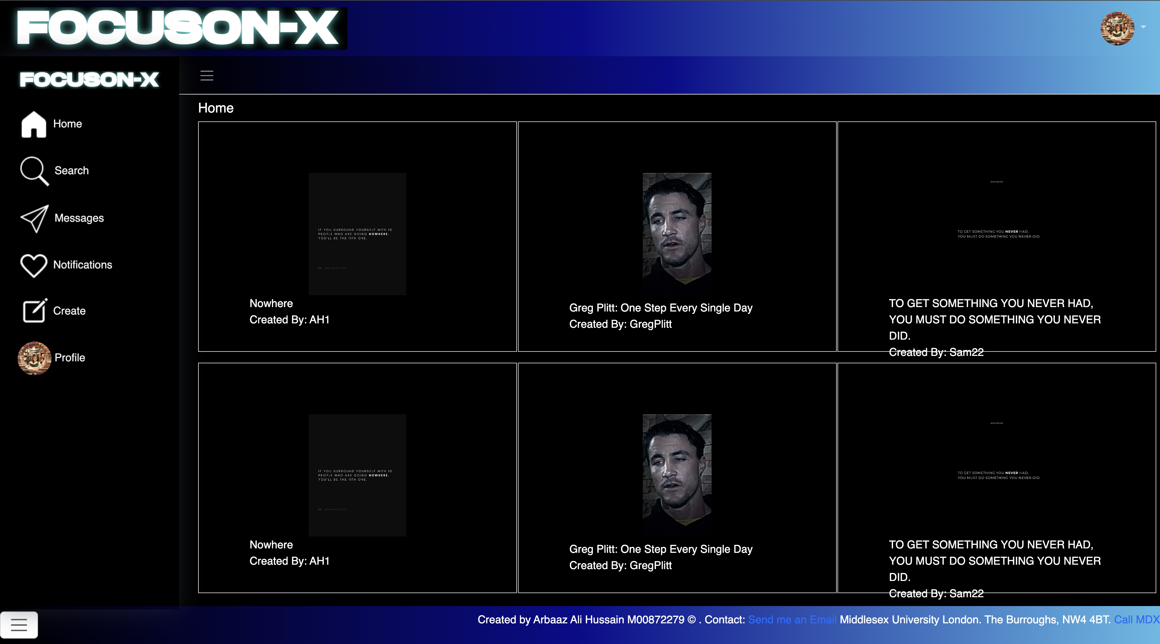

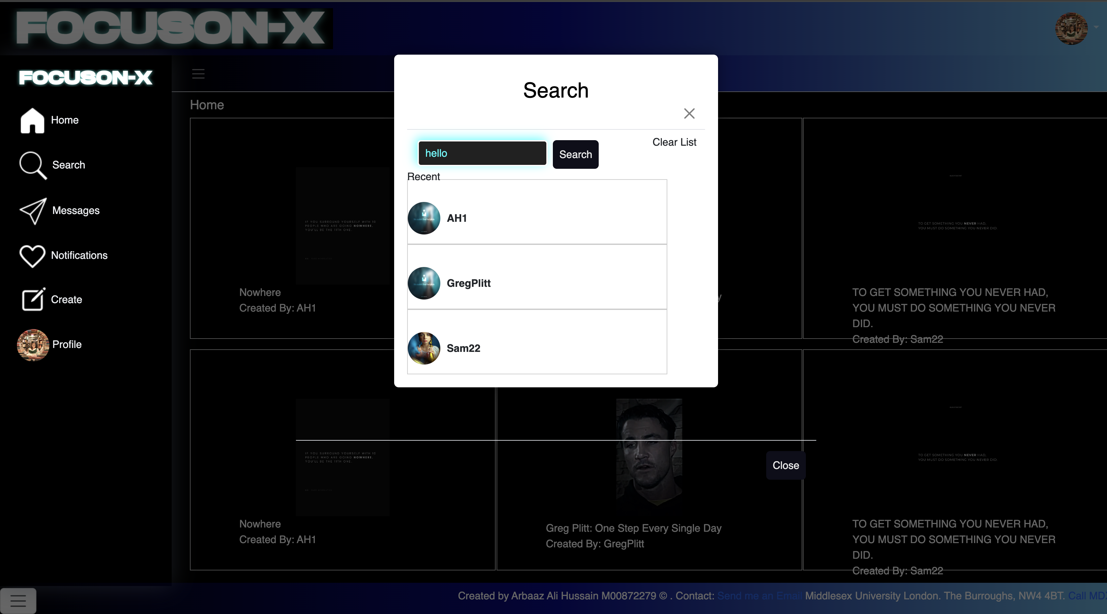

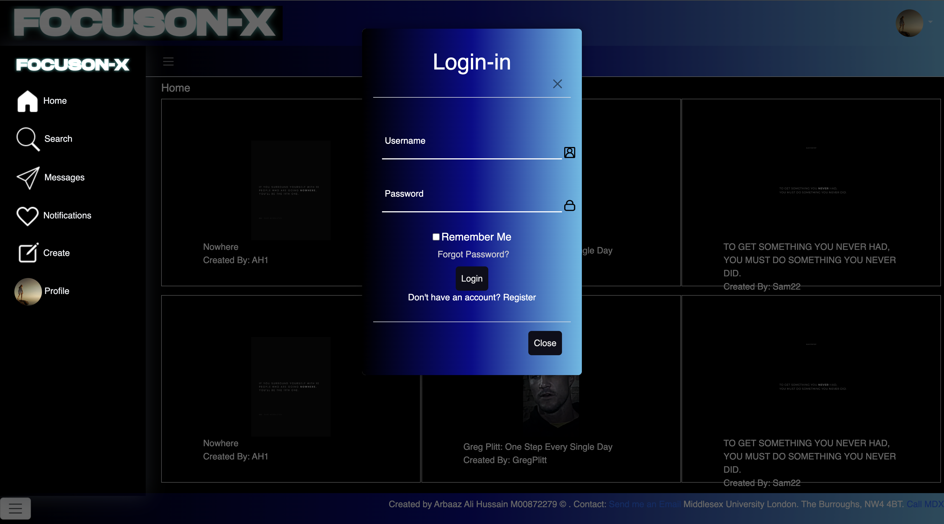

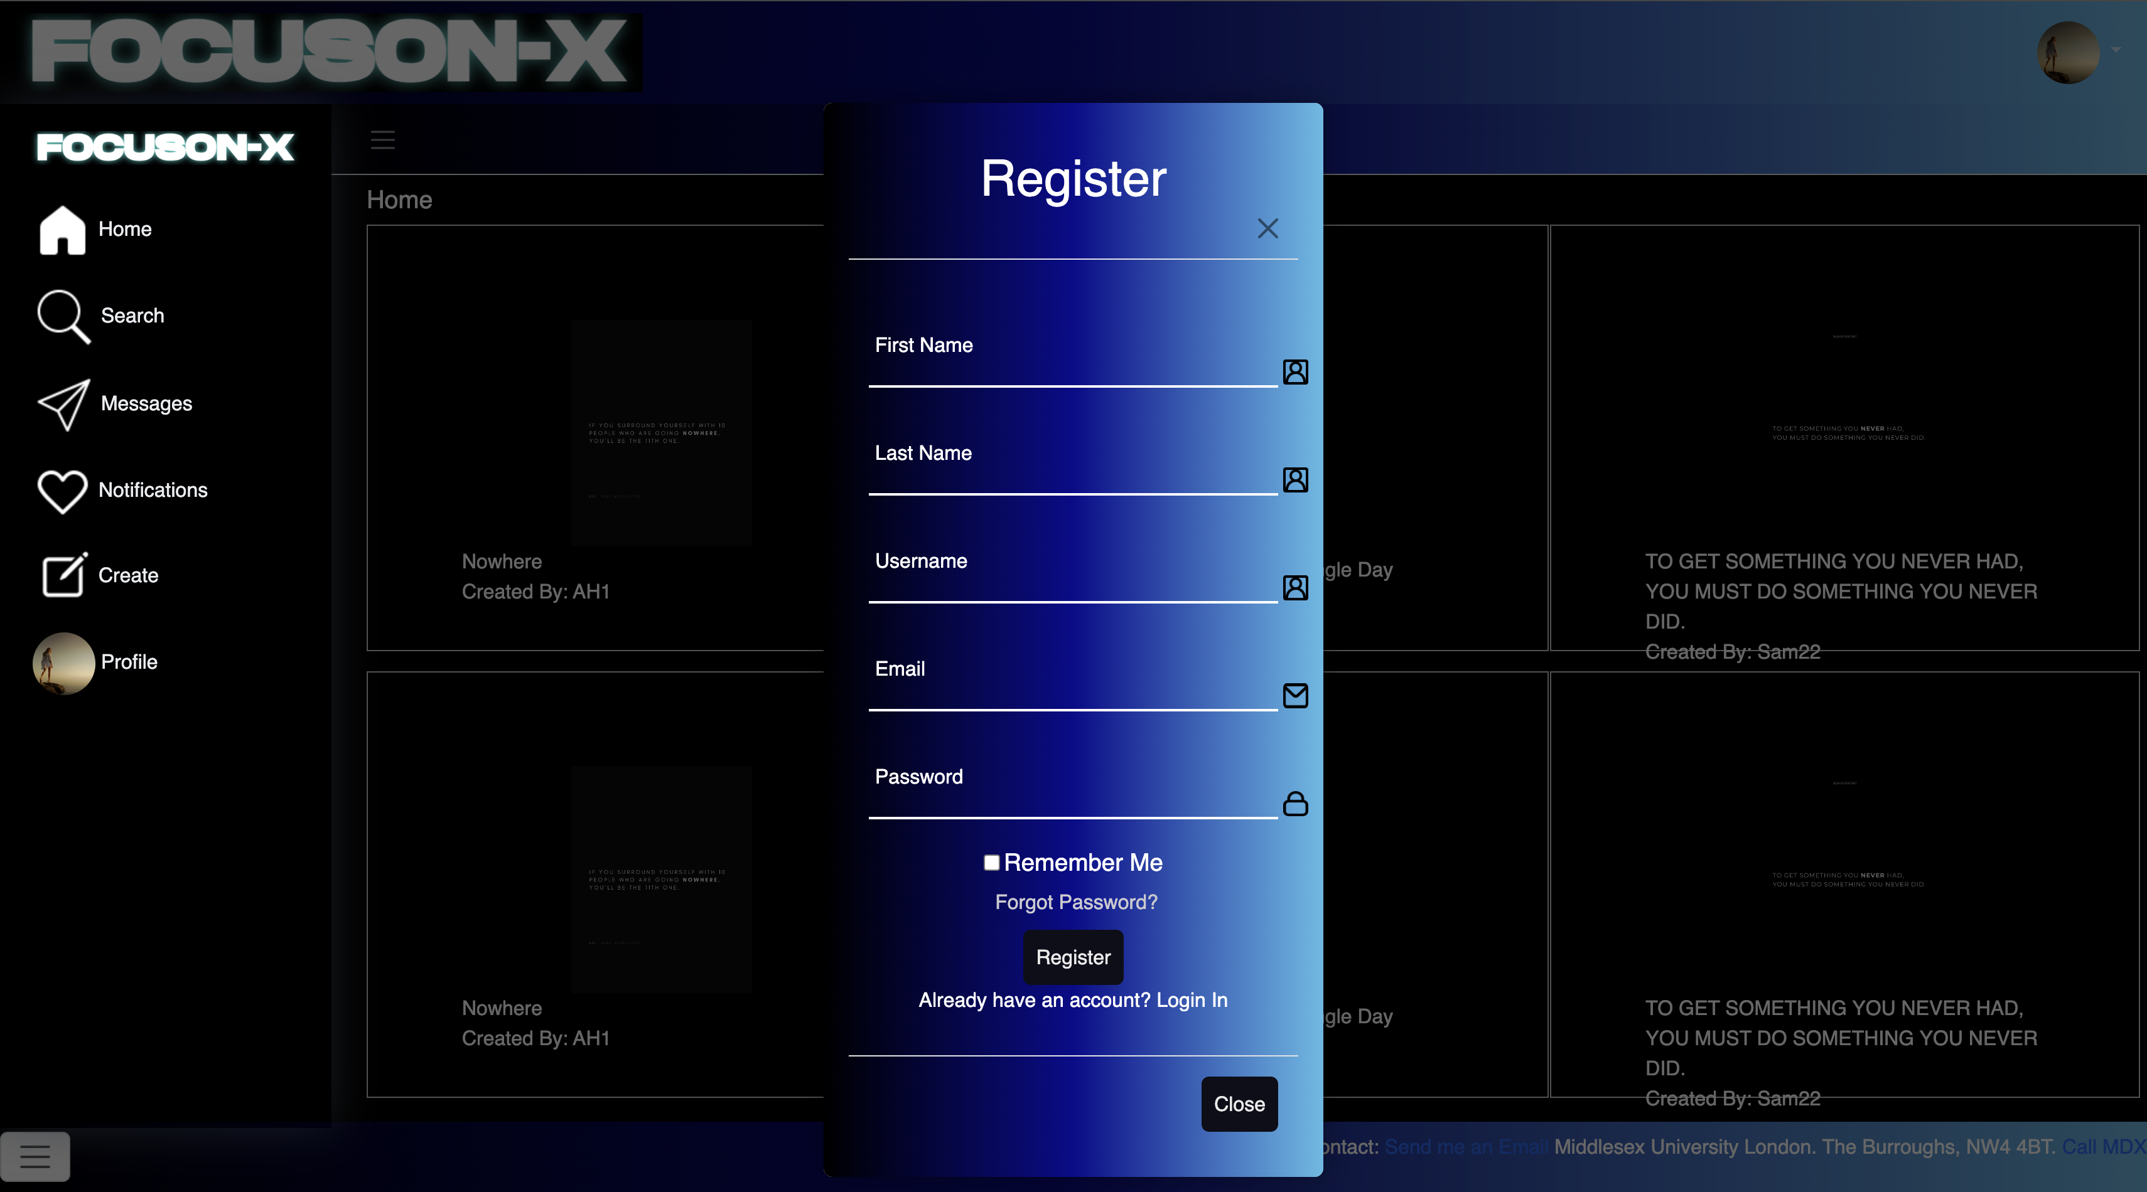

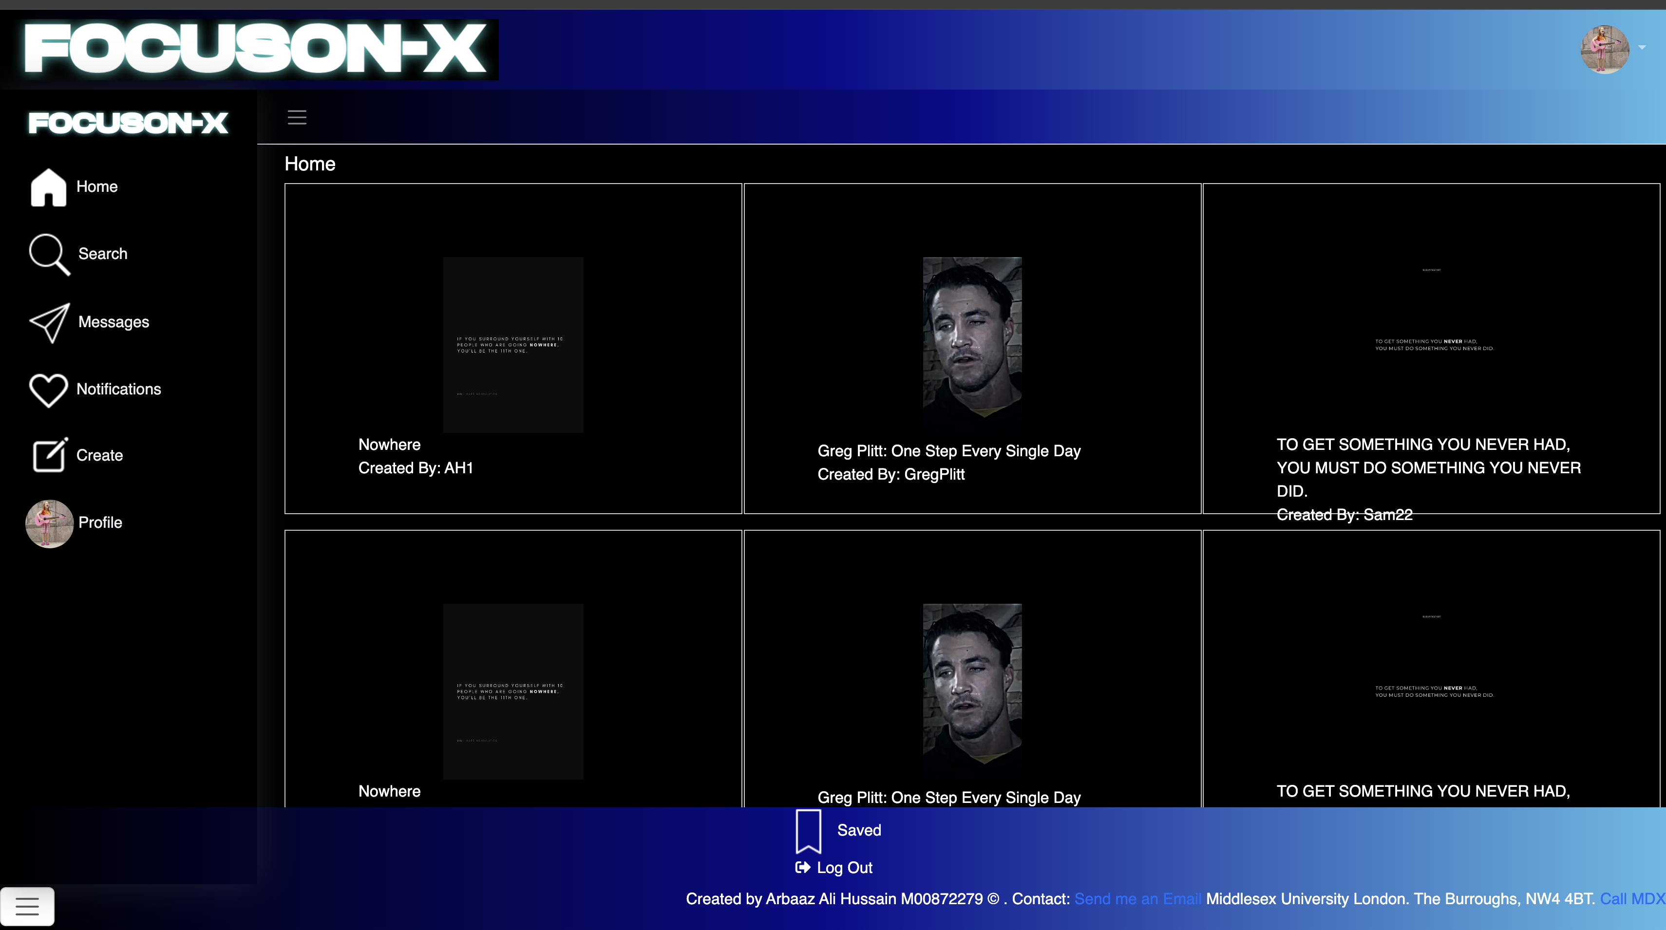

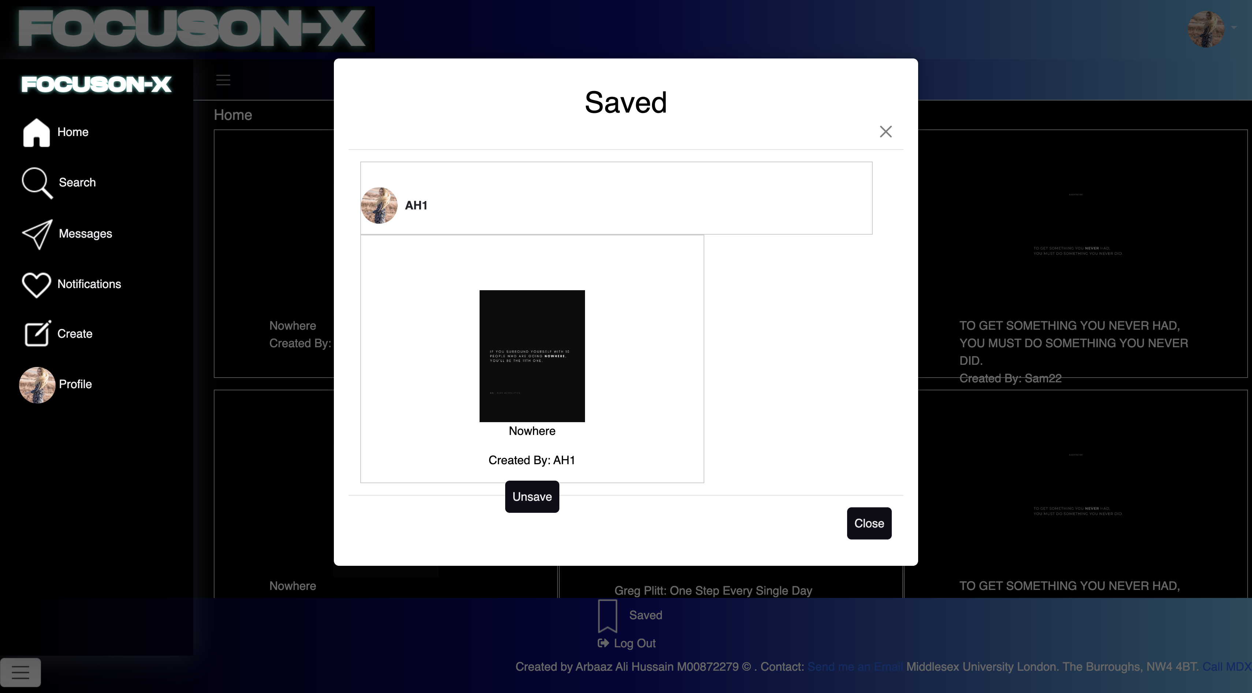

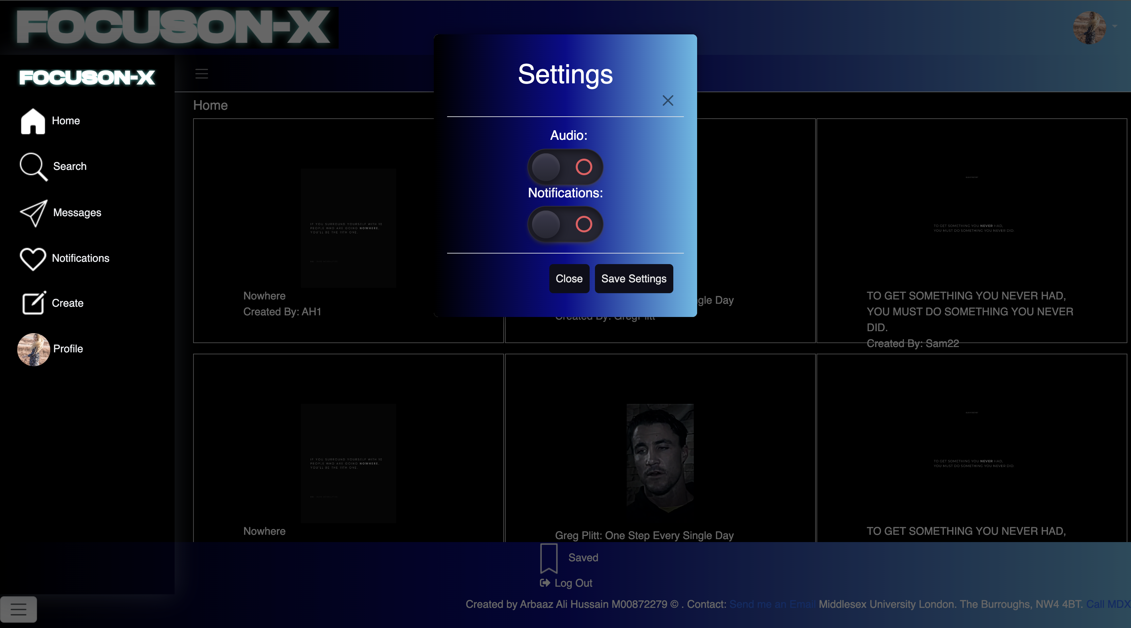

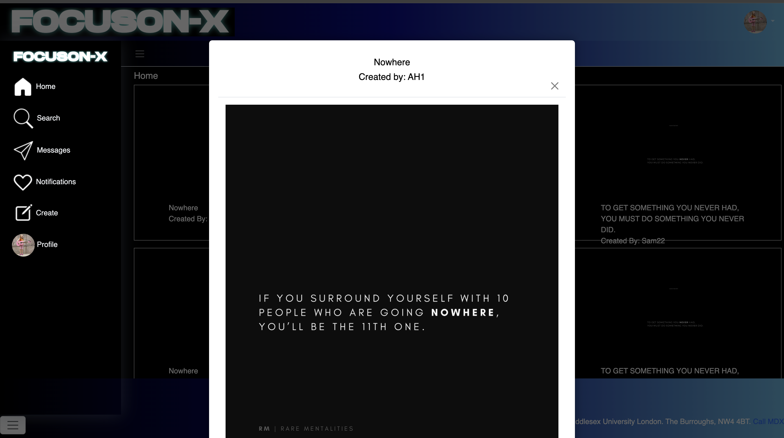

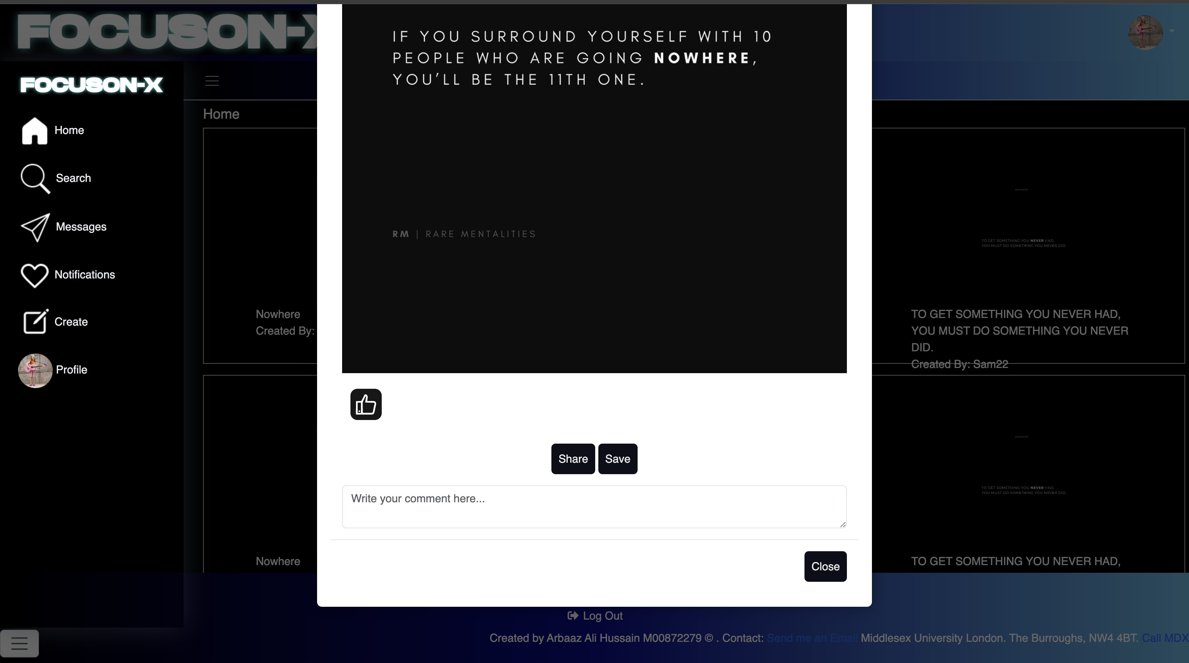

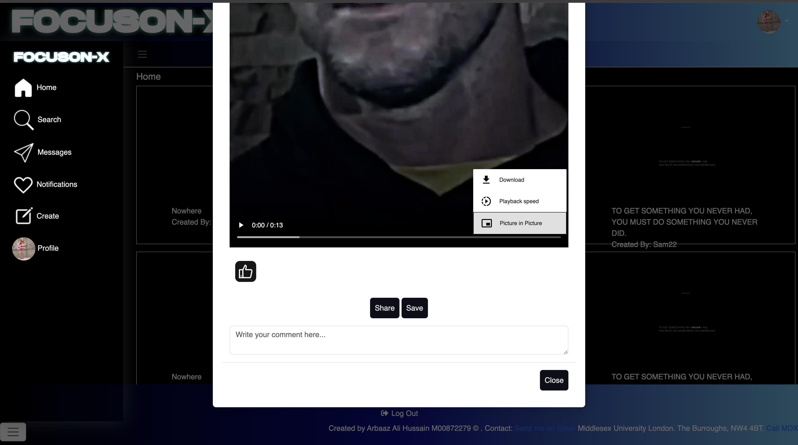

# The Social Media Website / FocusON-X Postman /Thunder Client Screenshots

